Habitare annual complaints and service improvement report and compliance with The Complaint Handling Code

- Introduction
This report summarises complaints received during 2025, including the key themes of those complaints, outcomes and service improvements implemented in response. In line with the Regulator of Social Housing’s Transparency, Influence and Accountability Standard, Habitare Homes (Habitare) publishes information on the number, nature and outcomes of complaints.
Habitare is a member of the Housing Ombudsman Service and operates in accordance with the Housing Ombudsman’s Complaint Handling Code. As such we operate a two-stage complaints process and publish our complaints policy on our website. We also publish out compliance with the Housing Ombudsman's Complaint Handling Code annually.
During 2025, our homes were managed by three managing agents: Amplius Living, Raven Housing Trust and Touchstone Property Management.
In 2025, Habitare's housing stock grew by 80% from 259 to 467 homes, while total complaints reduced from 44 to 38, with complaints per 100 homes falling from 17.0 to 8.1. The Stage 2 escalation rate dropped from 42% to 31%, and defect-related complaints fell from 86% to 55% of all complaints, following improvements to our defect management and coordination processes.
While we are pleased with this progress, we recognise that more work is needed. Defect resolution — particularly at schemes impacted by developer insolvency — remains the leading driver of complaints and a key priority for 2026. We are focused on strengthening managing agent oversight, improving the timeliness and quality of complaint responses, and ensuring residents receive clearer, more frequent updates on repairs and defects. The sections that follow set out our performance in detail, the themes we have identified, and the actions we are taking to continue improving.
- Complaint Handling Code compliance and self-assessment
Habitare confirms that we are compliant with the Housing Ombudsman’s Complaint Handling Code. We have completed our annual self-assessment against the Code and are satisfied that our complaints policy, two-stage process, response timescales, escalation arrangements and learning from complaints meet the Code’s requirements. We will keep our compliance under review through regular performance monitoring with our managing agents and will update our self-assessment if any material changes are required.
- Complaints Handling and Communication Standards
Our policy states that complaints are acknowledged within five working days of receipt and logged by the managing agent responsible.
- Stage 1: Investigated and responded to within 10 working days.
- Stage 2: Where escalation is requested, the complaint is referred to Habitare and a written response is issued within 20 working days. if we need more time, we will explain why, agree a new date with the resident, and keep them updated.
- Following completion of our process, complainants may refer their complaint to the Housing Ombudsman Service.

Metric | Target | 2025 Performance
Stage 1 resolved within 10 working days | 100% | 97%
Stage 2 resolved within 20 working days | 100% | 100%

One of our managing agents missed one Stage 1 response deadline. To prevent this happening again, we have introduced a new report that logs the date each complaint is received and the date the response is due. This report is shared with Habitare, so we can see every complaint received and every response issued, monitor progress, and ensure deadlines are met.
- Annual Overview (2025)
During 2025, we recorded a reduction in total complaints (at both stage 1 and stage 2) compared with 2024:

Year | Total Complaints | Stage 1 | Stage 2 | No. of homes | Complaints per 1,000 homes
2024 | 44 | 31 | 13 | 259 | 17.0
2025 | 38 | 29 | 9 | 479 | 7.9

Our housing stock increased by 80% year-on-year, from 259 homes (2024) to 467 homes (2025). When adjusted for stock size, complaints performance improved, with complaints per 1,000 homes reducing to 8.1% in 2025 (from 17% in 2024). [The number of Stage 2 complaints received in 2025 has reduced by 4 cases] Escalation rate from a Stage 1 to a Stage 2 complaint in 2024 was 42%. This year, this has reduced to 31%, representing an 11 percentage point improvement in resolving complaints at the first stage.We introduced a number of service improvement measures during 2025, particularly in defect management and complaint handling, which have contributed to improved performance. However, defects remain the most significant driver of complaints and continues to require focused attention [and improvement].
- Housing Ombudsman Referrals
Two complaints were referred to the Housing Ombudsman Service in 2025 and are still under investigation awaiting review and determination.
Lewes: referral about delays in resolving defects after the developer entered liquidation.
Towergate: referral about the shared ownership sales process.
The Ombudsman’s decisions are expected in 2026.

- Complaint Profile and Key Themes

6.1 Primary cause: new-build defects
New-build defects remained the leading cause of complaints in 2025, representing 55% of all complaints. This continues to be a key risk area, particularly where defect resolution is complicated by developer insolvency and the coordination is required across multiple parties.
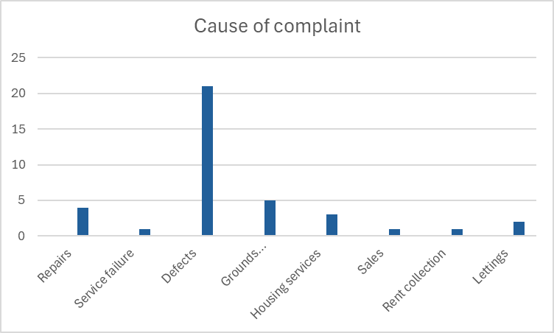
To strengthen our approach:
- Defect tracking processes have been improved and are now reviewed on a weekly basis in line with consumer standards requirements for transparency. Discussions are initiated before handovers and resident occupation take place. For sites in defect periods, agreed processes are in place between all parties for reporting, tracking, and resolving defects. These are supported by formal defect charter agreements that all parties are committed to delivering.

- Habitare coordinates regular meetings with its developers and managing agents to progress outstanding issues, ensuring oversight of all parties and adherence to the commitments made in the defects charter.
- Where appropriate, retention monies are being used more effectively. For example, when a resident raises an issue and it is unclear whether it is a defect or a repair, we take a proactive approach by completing the repair first to resolve the issue for the resident. Once the work is completed, we then engage with the developer to determine whether the repair should be classified as a defect, particularly where there is a dispute. This ensures that the issue is resolved for the resident as soon as possible.

6.2 Concentration risk: Grantham and Lewes
Complaints remain disproportionately concentrated in two of Habitare's schemes:
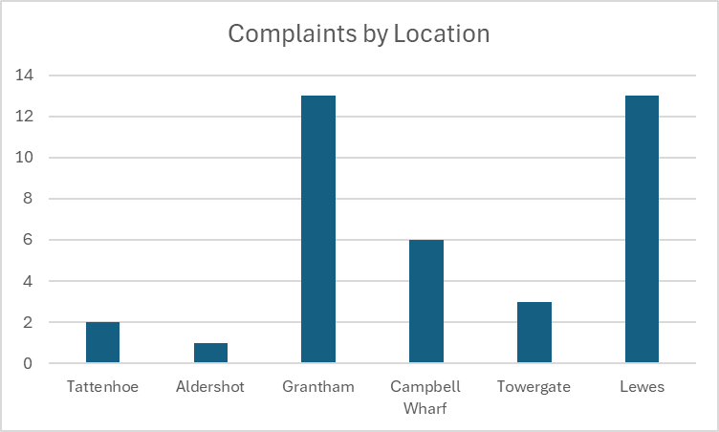

Grantham and Lewes account for 26 of 38 complaints (68%)
This concentration of complaints at these two sites requires continued focus on defect management, where developer insolvency has created additional barriers to timely resolution. We continue to work with our managing agents, replacement contractors and NHBC to try and resolve these issues. Given the complexity involved when a contractor has gone insolvent there are clear industry processes to follow with respect to defects which can seem slow and bureaucratic. We sympathise with the frustration that this can cause and that residents have legitimate complaints with respect to these issues. We will work to put things right fairly and without unnecessary delay.
6.3 Tenure: shared ownership sees more complaints
Complaint volumes and escalation rates indicate that shared owners are more likely both to raise complaints and to escalate them:
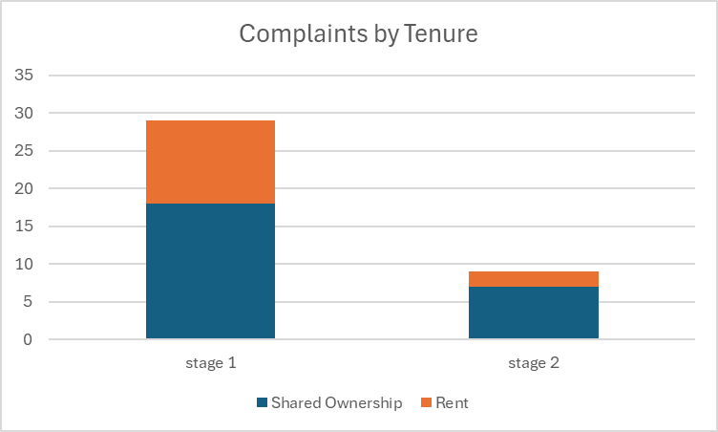

Stage 1: 62% Shared Ownership; 38% Rent
Stage 2: 78% Shared Ownership; 22% Rent
This reflects the nature of the issues raised: the majority of Stage 2 complaints were defect-related, and shared owners, in particular, have expressed frustration with the duration and complexity of defect resolution.
6.4 Secondary themes
Beyond defects, secondary themes include:
- Grounds maintenance/estate services
- Housing services
Together these accounted for 21% of complaints, indicating areas where service standards and delivery can fall short requiring ongoing monitoring. We are proactively implementing measures to address these themes before they escalate to formal complaints. Service improvements already in place include:
- Site inspections: Regular inspections are being conducted to monitor service standards, with Amplius Living carrying out checks at Campbell Wharf and Touchstone at Aldershot.
- Resident feedback loops: We are establishing mechanisms to capture resident feedback early, enabling us to address concerns before they escalate to formal complaints.
- Performance management: Monthly meetings are held with managing agents to analyse performance data, identify any underperformance, and understand the root causes to drive improvement.
- Fairness in complaint handling
We did not refuse escalation of any complaints during 2025. Residents continued to have access to a clear, two-stage process and the ability to escalate to the Housing Ombudsman following completion of our internal process.
- Lessons learned
Working alongside our managing agents, we identified three key lessons:
- Meeting response times: Stage 1 performance fell below our target. We have agreed targeted training and additional resource with the relevant managing agent and strengthened monitoring.
- Keeping residents updated: Managing agents must provide residents with updates at least every two weeks on defect and repair progress.
- Stronger oversight of defect resolution: We will increase scrutiny of complex cases to ensure all parties meet agreed actions and deadlines
Service Improvement
In response to the high escalation rate and recurring themes identified in 2024, Habitare Homes implemented improvements during 2025. As a result, defect-related complaints reduced from 86% to 55% of total complaints. Despite this improvement, defects remain the dominant driver of dissatisfaction and continue to require priority attention.
A key driver of complaints, particularly those escalating to Stage 2, has been the complexity of certain defect cases, which has extended the time needed to reach root cause and implement effective remediation. This has, at times, led to delays and compounded with this are insufficiently clear updates from managing agents and contractors, which residents have cited as a significant contributor to dissatisfaction. While some complex cases remain ongoing, defects at Grantham and Lewes remain a priority, and we continue to work with partners to drive these to resolution.
To strengthen complaint resolution quality and consistency, we developed an AI-supported review tool to assist managing agents in ensuring complaint responses:
- address all issues raised by the resident;
- align to Habitare Homes policy; and
- reflect the Housing Ombudsman’s Complaint Handling Code requirements.
This tool has been used for both Stage 1 and Stage 2 complaints at Aldershot and is supporting improved oversight and response quality.
We will continue to monitor performance through monthly reviews with our managing agents. KPIs are included in all agreements to ensure consistent, timely complaint handling for all residents.
- Conclusion
Habitare Homes takes complaints seriously and considers complaint management a key service priority. While total complaints reduced in 2025 and performance improved when adjusted for stock growth, defects, particularly in schemes affected by developer insolvency, remain the leading cause of complaints and escalation. Our focus for 2026 remains on strengthening defect resolution, improving the clarity and frequency of resident updates, and embedding consistent, high-quality complaint handling across all managing agents. We recognise the impact these issues have had on residents and will continue to work with our partners to address the concerns raised.
- Governance
This report will be reviewed by the Habitare board at the first QBM of 2026.

